Study of Different Types of Motors and Their Workings

Vyas Bodke
Research Subsystem
Robo Manipal, MIT
Manipal, India
vyas.mitmpl2026@learner.manipal.edu

Abstract— This report discusses the construction, working principles, characteristics and applications of DC, BLDC, servo, stepper, smart servo, induction, synchronous, reluctance and permanent magnet synchronous motors.
Keywords—component, formatting, style, styling, insert (key words)

Introduction
A motor converts electrical energy into mechanical energy. Motors are used in many daily use machines. Some motors in the report are used for continuous movement, and others are used for precision.
Most motors have these parts.
The stator is the part that stays stationary, the rotor is the part that rotates. The shaft connects the rotor to the outside for required use. Bearings support the shaft and reduce friction. Windings are wires that are insulated and produce a magnetic field when current flows through them.
Torque and speed are also given for a motor, torque is the turning force it gives, and speed is in revolutions per minute (rpm.

DC Motors

Construction
The DC Motor has the following:
The stator uses permanent magnets or windings as electromagnets to produce a magnetic field. The rotor has multiple insulated wire windings around an iron core.
The brushes are usually made of carbon and are used to carry current from the supply to the rotating commutator. The commutator is made of copper segments separated by insulation and is connected to the rotor field windings. It allows the coils to be switched and current to change directions giving continuous motion.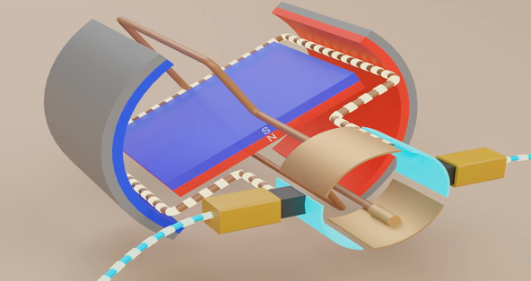
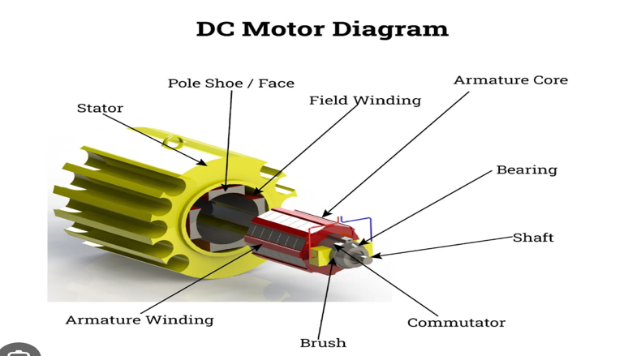

Working Principle
The DC Motor works on the principle of Lorentz Force. This force acts on a current carrying conductor is placed in an external magnetic field. This is what is present in the motor. It is given by
$$F=Ilbsin\left(\right)$$

I is the current passing throught he coil, L is the length of the coil, B is the magnetic field across it and theta is the angle between current and magnetic field. We can figure out any of the parameters direction using the other two with the Flemings Left Hand Rule.
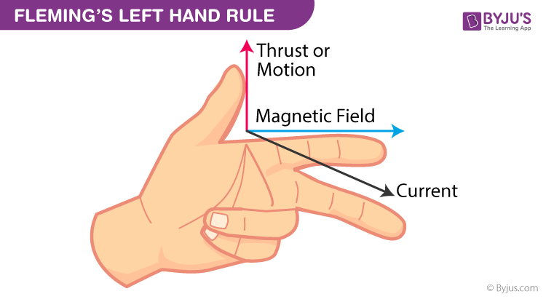
The motor’s shaft rotates due to the coils inside experiencing the force due to current. When a coil gets to a middle position where angle is perfect, the segment in the commutator changes and reverses current thus keeping it constantly moving while power is supplied.

Types and Characteristics
Permanent magnet DC motors use fixed magnets. In series motors, the field winding and armature are in series, giving high starting torque. In shunt motors, they are in parallel, giving steady speed. Compound motors use both series and shunt connections.

Advantages are low cost and simple control for speed. The disadvantages are damage to brushes due to continuous use and thus maintenance is needed.

The gearbox helps the motor move the load at a lower speed. An encoder can be added to measure the wheel speed or position.

Applications

DC motors are used in robot wheels because they are easy to control and reverse. They are also used in toys.

Brushless DC Motors

Construction
The BLDC motor has windings on the stator and permanent magnets on the rotor. It does not have brushes or a commutator. It has a shaft and bearings as well and an outer frame. It needs an electronic controller to supply current to the windings in the correct order and needs a sensor to know the position of the rotor, mostly a hall effect sensor (IC here means integrated circuit).
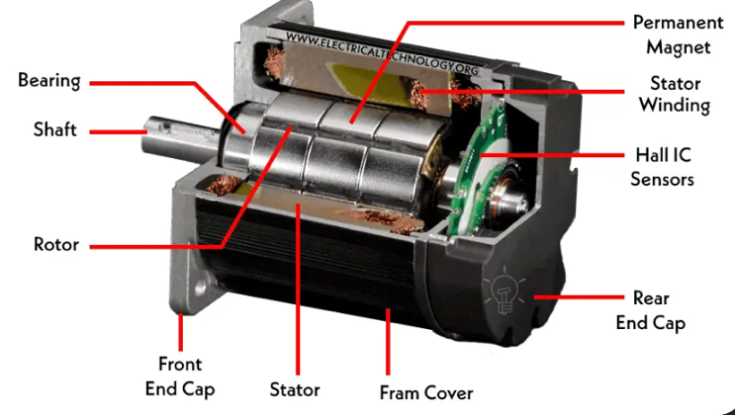
The rotor has 14 magnets, but the stator has 12 coils commonly. This is to prevent them from aligning and always keeping them moving. 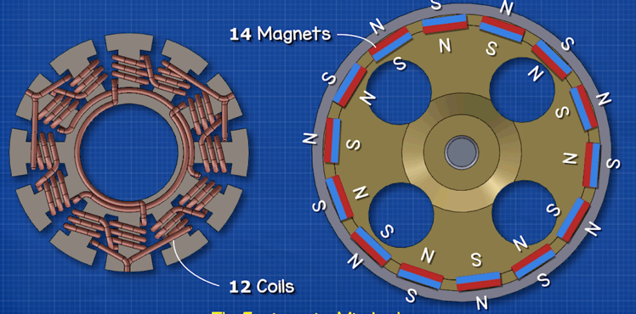

Working
The controller switches current between the stator windings in mostly three phases to make a moving magnetic field. The rotor magnets follow this field, producing rotation and torque. The controller keeps switching the windings as the rotor moves.
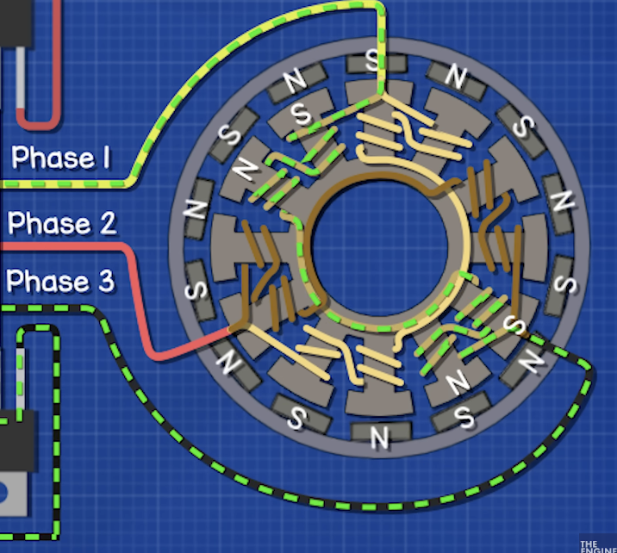
The controller is used for accurately using the three phases to keep it in motion along with pulse width modulation. The increase in width of the pulse causes increase in motor speed.
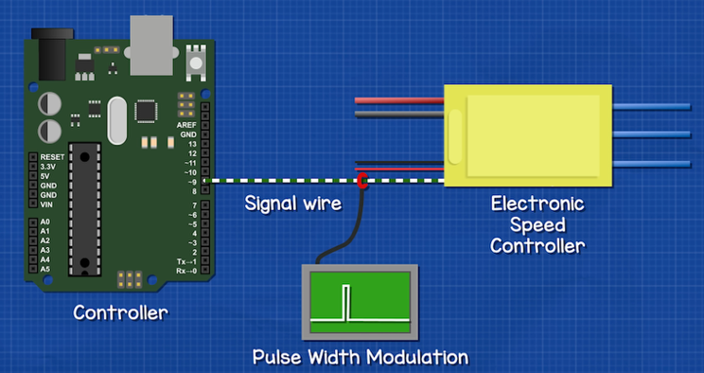
Some motors use Hall sensors to detect the rotor position. Others estimate it from electrical signals like back EMF. Back EMF is generated in the coil which is non energised. This can be used to keep track of the currents in the three phases. Even though the supply is DC, the controller keeps changing the current through the motor windings.

Types and Characteristics
In inrunner BLDC motors, the rotor is inside the stator. In outrunners, the outer part containing the magnets rotates around the stator. They can also be sensored or sensorless, depending on how rotor position is detected.

BLDC motors are efficient and last longer without brush replacement. Their main disadvantages are the extra controller and higher cost.

Applications
Drones use BLDC motors because they need motors that are light and powerful. They are also used in cooling fans, electric bicycles and cordless tools.

Servo Motors

Construction

A servo is a motor system that uses feedback to control its movement. It includes a motor, controller, driver and position sensor. An example of a servo motor has a DC motor, gears, a potentiometer and a control circuit inside one case. Industrial servos often use brushless motors and encoders.
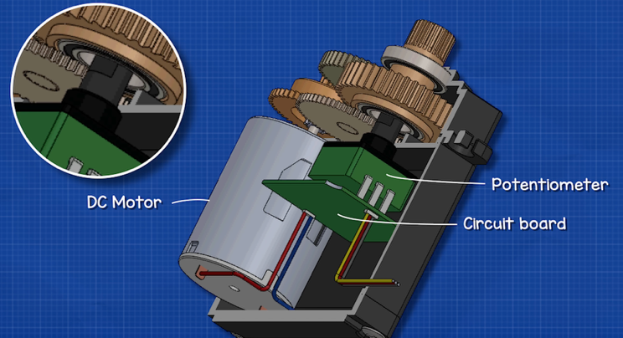

Working
The controller measures the required position and the actual position measured by the sensor. The difference is called the error. It controls the motor to reduce this error. For example, if a servo is told to move to 90 degrees, it turns towards that position and uses the sensor to constantly correct its movement. The comparator and the potentiometer are used for that specifically.
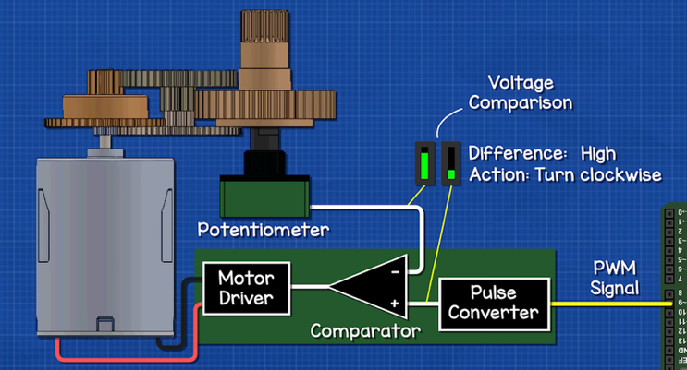
There is a motor driver which uses a H- bridge to control the direction and movement of the motor. The H bridge has switches which can be used to change the directions of current in the coils which can be used to move the motor accordingly.
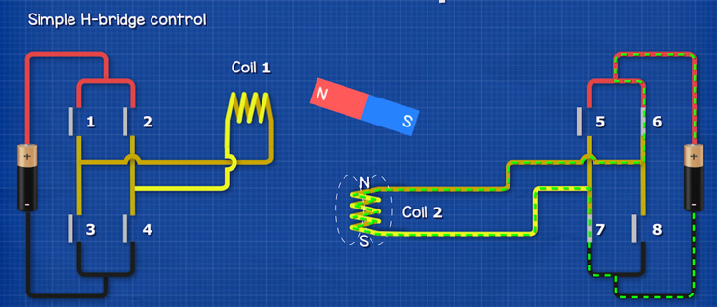

The motor produces the torque, while the controller decides how much current to send to it. If a load tries to move the shaft away from its position, the controller can apply more torque to hold it.

Types and Characterisitcs
Servos give precise movement and can correct position errors. They cost more than a basic motor and need a sensor and controller. Loose movement between gear teeth can reduce accuracy.
The types of servo include a smart servo which is discussed later.

Applications
Robotic arms use servos to move to required angles. They are also used for steering in remote controlled cars and for accurate movement in industrial machines.

Stepper motors

Construction
A hybrid stepper motor has stator windings and a rotor made with magnets or iron or both. The rotor has two cups which are north and south poles and they are not aligned with each other. It has minute teeth which allows it to move through small angles called steps. The stator also has teeth but the rotor has more teeth than the stator.
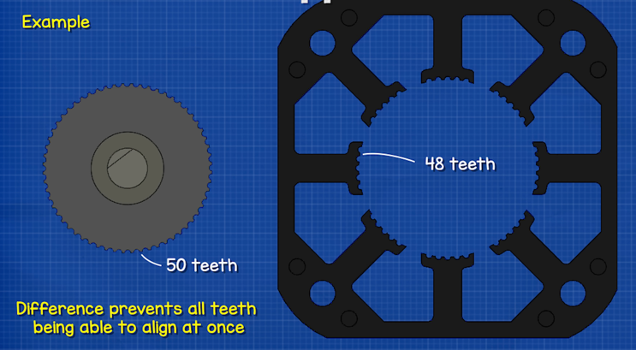

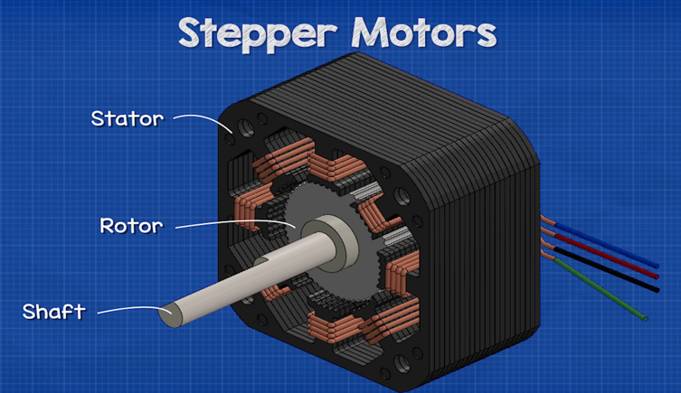

It has a controller and a motor driver along with shaft and bearings. A common step angle is 1.8 degrees, which gives 200 full steps for one revolution, which is 360/200 = 1.8

Working
The driver sends current through the windings in a sequence. The rotor turns to line up its teeth with the teeth of the energized winding. When the next winding is energized, the rotor moves to the next position. This produces torque.
The two parts of the rotor line up separately with the teeth and thus give better torque.
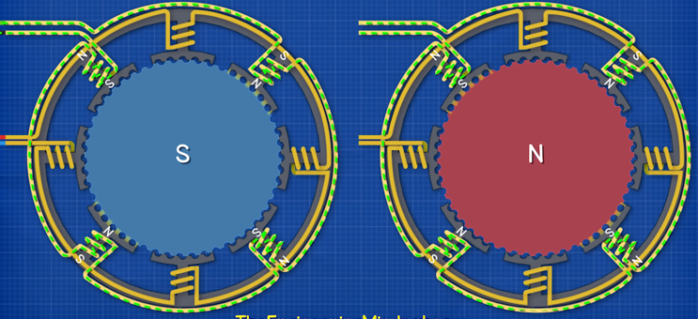
The motor’s precision is controlled by the controller and motor driver by multiple methods like wave drive, full step, half step, and micro step. The most used one is micro step which allows a smoother rotation.

Types and Characterisitcs
Permanent magnet steppers have a magnet rotor. Variable reluctance steppers have a toothed iron rotor. Hybrid steppers combine magnets and teeth.
Steppers are useful for simple position control and can hold their position when powered.

Applications
Steppers are widely used in 3D printers and other precision requiring machines. These devices need repeated movements by known amounts. The speed and acceleration should stay within the motor's limits to avoid missed steps.

Smart Servos

Construction

A smart servo is a type of servo that combines a motor, gears, sensor, driver and processor in one unit. It also has a digital connection through which it receives commands and sends information back to the main controller.

Working
The main controller sends a command, like an angle or speed. The smart servo uses its own sensor and control circuit to carry out the movement. Its motor produces the torque in the usual way. The extra electronics handle feedback and communication.
It can report position, speed, current, temperature and supply voltage acc to its model.

Types and Characterisitcs
Different models have different sensors and inputs and outputs. The advantages of smart servo are easy wiring, built in control and feedback about what the motor is doing. The disadvantages are higher cost and extra setup.

Applications
Smart servos are useful in humanoid robots and robotic arms with many joints.

Induction Motors

Construction
An induction motor has a stator with AC windings and a rotor separated from it by a small air gap. A squirrel cage rotor has metal bars joined by rings at both ends. It has a shaft and bearing and a fan for cooling attached to the shaft. It has a frame and covers as well.
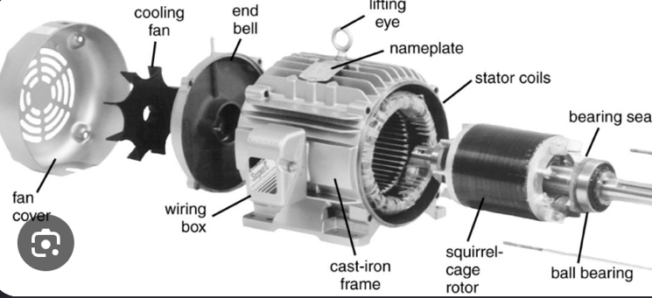

Working
In a three-phase motor, the stator currents create a rotating magnetic field RMF. This field induces current in the rotor bars. The end rings connect the rotor bars to form closed paths for induced current. The laminated iron core reduces eddy current losses. The rotor current interacts with the magnetic field and produces torque, making the rotor turn.
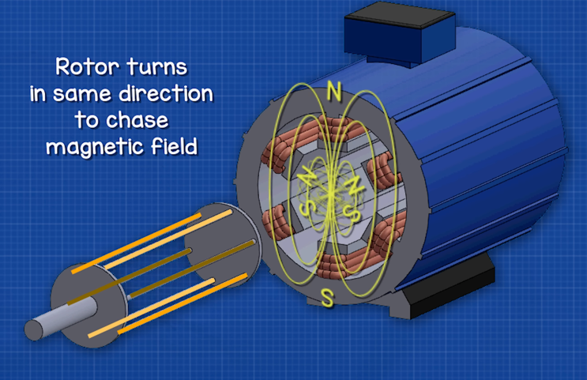
The rotor runs slightly slower than the rotating field. This difference is called slip. If the rotor reached the same speed as the field, there would be no relative movement to induce rotor current and produce torque.

The field speed is given by
$nₛ = 120f/P$

Here, ns is the speed in rpm, f is supply frequency in hertz and P is the number of poles. At 50 Hz, a four-pole motor has a field speed of 1500 rpm. If the rotor runs at 1440 rpm, the slip is 1500 – 1440)/1500 = 4 percent

Types and Characteristics
Induction motors can be single phase or three-phase. Three-phase motors are self starting. Single phase motors need extra starting arrangements. Induction motors are strong, reliable and need little maintenance. To control speed over a wide range, a variable frequency drive or VFD is used. It changes the supply frequency and voltage.

Applications
Induction motors are used in pumps, fans, compressors and conveyor belts because they can run for long periods. Traditional ceiling fans often use capacitor run induction motors.

Synchronous Motors

Construction
A synchronous motor has stator windings that create a rotating field. The rotor can have DC powered rotor coils, permanent magnets or a special iron shape used for reluctance. There is a shaft and bearing as well.
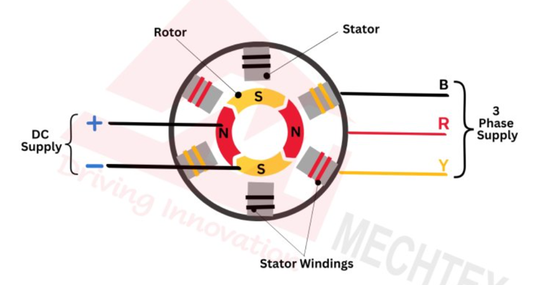

Working

The rotor follows the stator's rotating magnetic field at the same speed as it locks into the magnetic poles. In a wound field motor, the interaction between the rotor field and stator field produces torque. Under load, the rotor field stays slightly behind the stator field in angle, but both rotate at the same speed.
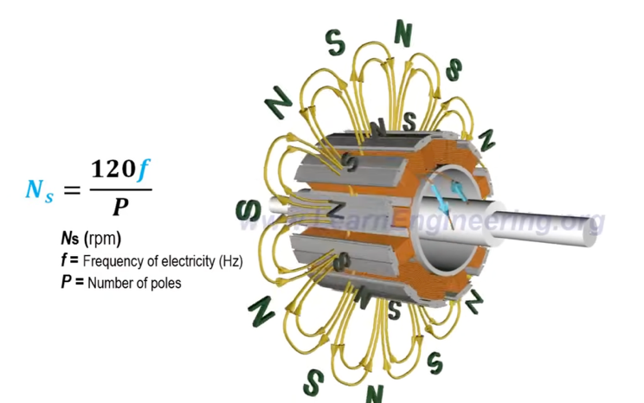

Its speed is given by the above formula.

It does not need slip during steady operation. If the load becomes too large, the rotor can fall out of step with the field.
It might need a starting arrangement to get it in sync with the RMF. A variable frequency drive can start the motor at a low frequency and gradually increase frequency and voltage.

Types and characteristics
The main types are wound field, permanent magnet and synchronous reluctance motors. The main advantage is constant speed at a fixed supply frequency.

Applications
Large compressors and mills can use synchronous motors where steady speed is useful.

Reluctance Motors

Working principle
Reluctance means opposition to magnetic flux. Magnetic flux passes more easily through iron than through air. In a reluctance motor, the iron rotor turns towards a position that gives the magnetic field an easier path. This produces torque without needing permanent magnets or coils on the rotor.

Construction
A synchronous reluctance motor has gaps inside its iron rotor called flux barriers. These make the magnetic field pass more easily in one direction than another. The rotor follows the rotating stator field at synchronous speed.
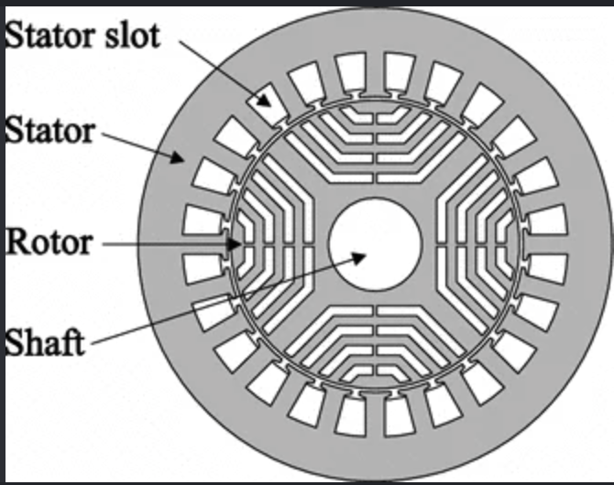
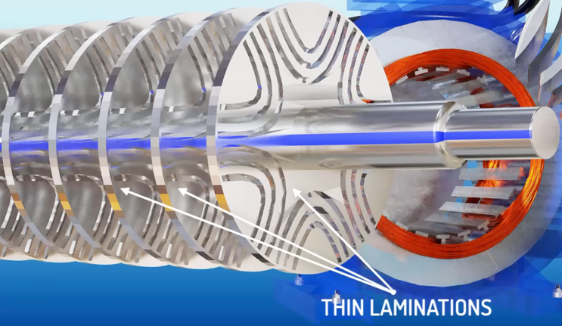
It has low rotor losses and does not need magnets in its basic form as compared to induction motors IsquareR loss(heat).

Applications
A modified version of them is used in electric vehicles wheels like Tesla

Permanent Magnet Synchronous Motors

Construction
A permanent magnet synchronous motor, or PMSM, has three-phase stator windings and permanent magnets on or inside the rotor.
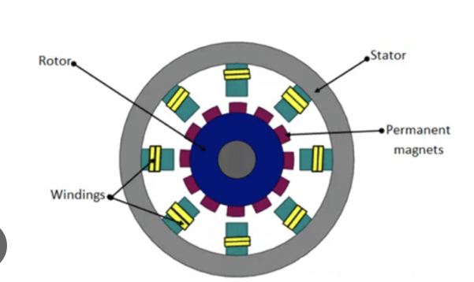

Working Principle
The stator currents create a rotating magnetic field. The rotor magnets follow this field at the same speed, and the two fields produce torque. The controller measures or estimates the rotor position so that it can supply current at the correct time. PMSMs commonly use smoothly changing, sine-wave currents. This operates with zero slip unlike induction motors.
Its speed is given by
nₛ = 120f/P

Types and Characteristics
Surface-mounted PMSMs have magnets on the rotor surface. Interior PMSMs have magnets inside the rotor.

Applications
PMSMs are used in electric vehicles and many other industrial uses. Their efficiency helps reduce power usage.

References

IEEE conference templates contain guidance text for composing and formatting conference papers. Please ensure that all template text is removed from your conference paper prior to submission to the conference. Failure to remove template text from your paper may result in your paper not being published.

